 | North Carolina Scrap Vehicle Reporting System  Registration Instructions

Gaining access to the North Carolina Scrap Vehicle Reporting System is a two-step process. The first step is to register with NCID to obtain your NCID user identification and password. The second step is to provide the NCID user identification and business information to the North Carolina State Highway Patrol to complete registration.
STEP 1. NCID Registration
The NCID Service is the standard identity management and access service provided to state, local, business and citizen users by the Office of Information Technology Services. NCID enables its customers to achieve an elevated degree of security and access control to real-time resources such as customer-based applications and information retrieval. Website: https://ncid.nc.gov
If you have questions specific to NCID, please contact the Office of Information Technology Services (NCID) Help Desk at 919-754-6000 or toll free at 1-800-722-3946.

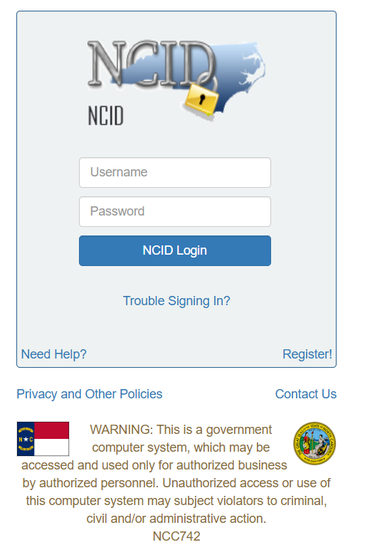

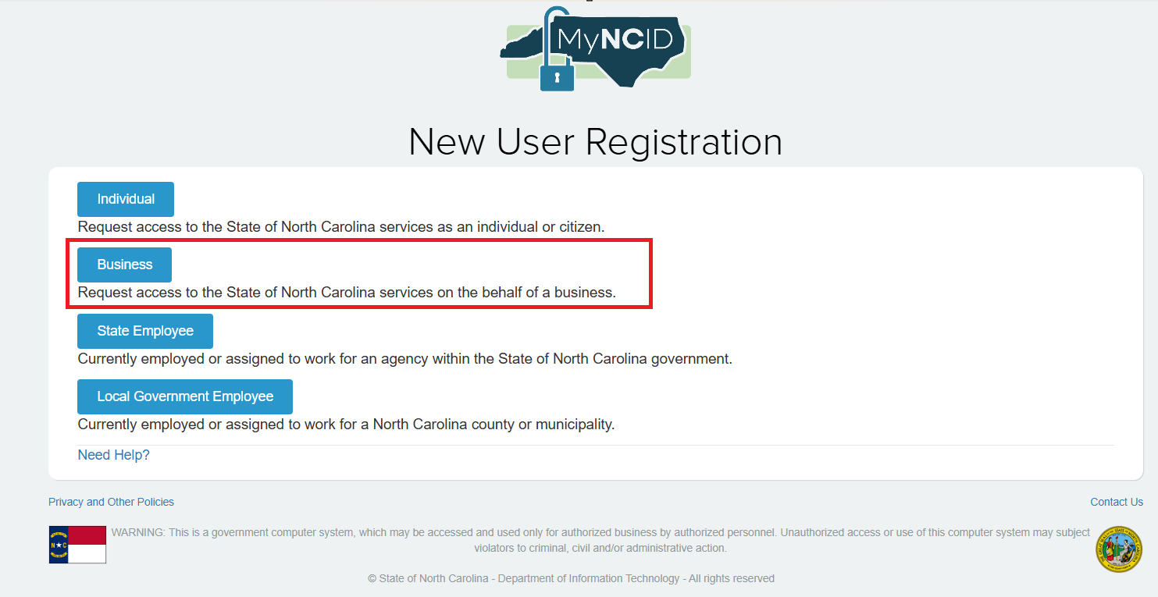

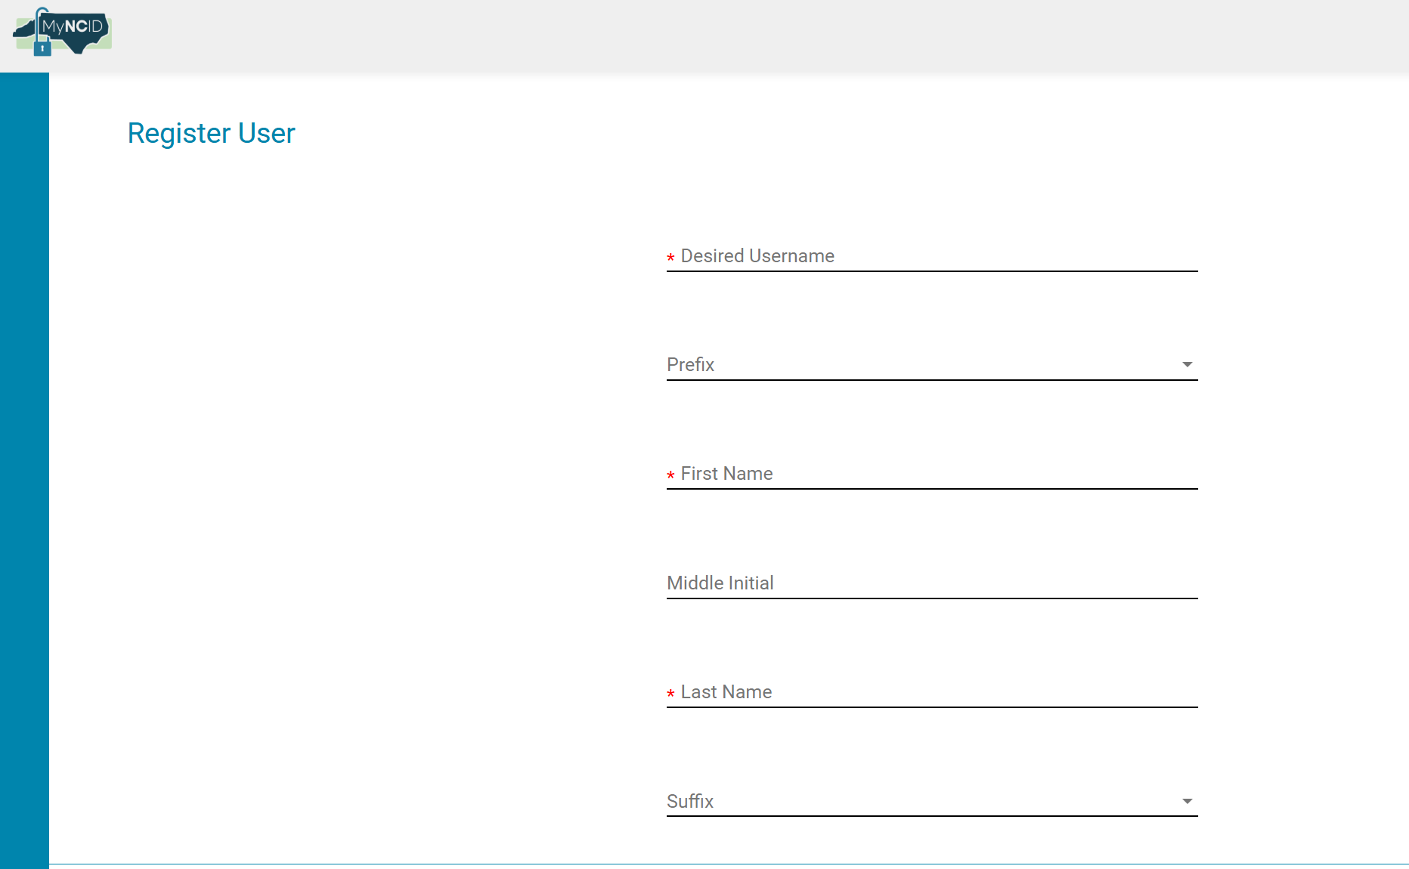
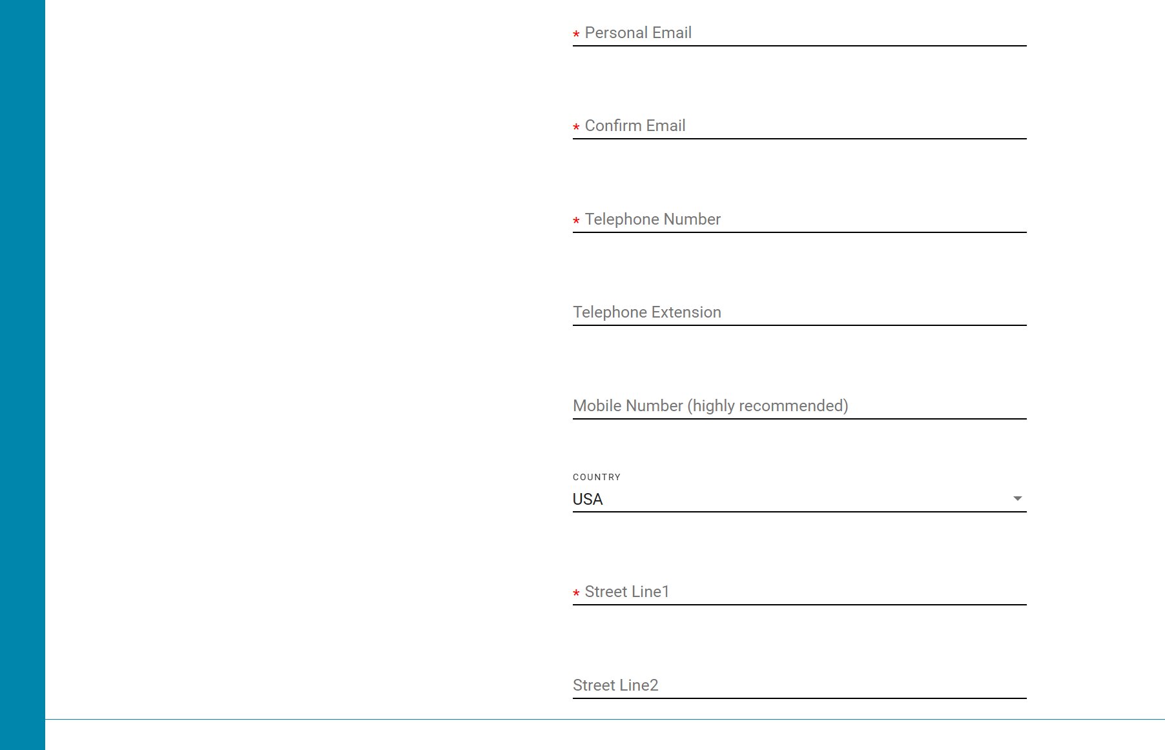

STEP 2. North Carolina Scrap Vehicle Reporting System Registration
Once you have registered with the State Information Technology Services and have received your NCID user identification, you will need to register with the North Carolina Scrap Vehicle Reporting System. To do this, email the North Carolina State Highway Patrol at veu@ncshp.gov with your NCID user identification, first and last name, business name and business phone number (if multiple businesses or sites, please send all business names, business addresses and contact numbers). Upon receipt by the North Carolina State Highway Patrol, the user account will be set up and active within one to two business days.

If you have questions specific to the North Carolina Scrap Vehicle Reporting System, please contact the North Carolina State Highway Patrol, Investigative Services Unit office in your area.
Investigative Services Unit, Fraud Section: 919-757-0751
Troop A – Greenville: 252-565-1321
Troop B – Fayetteville: 910-728-4601
Troop C – Raleigh: 984-268-5000
Troop D – Graham: 336-270-2290
Troop E - Winston-Salem: 336-793-9622
Troop F – Newton: 704-325-5535
Troop G – Asheville: 828-348-5780
Troop H – Huntersville: 704-331-3300

